**Experiment 9:** Create a Snapshot of a VM and Test it by loading the Previous Version/Cloned VM.

Step 1: Creating a New File.

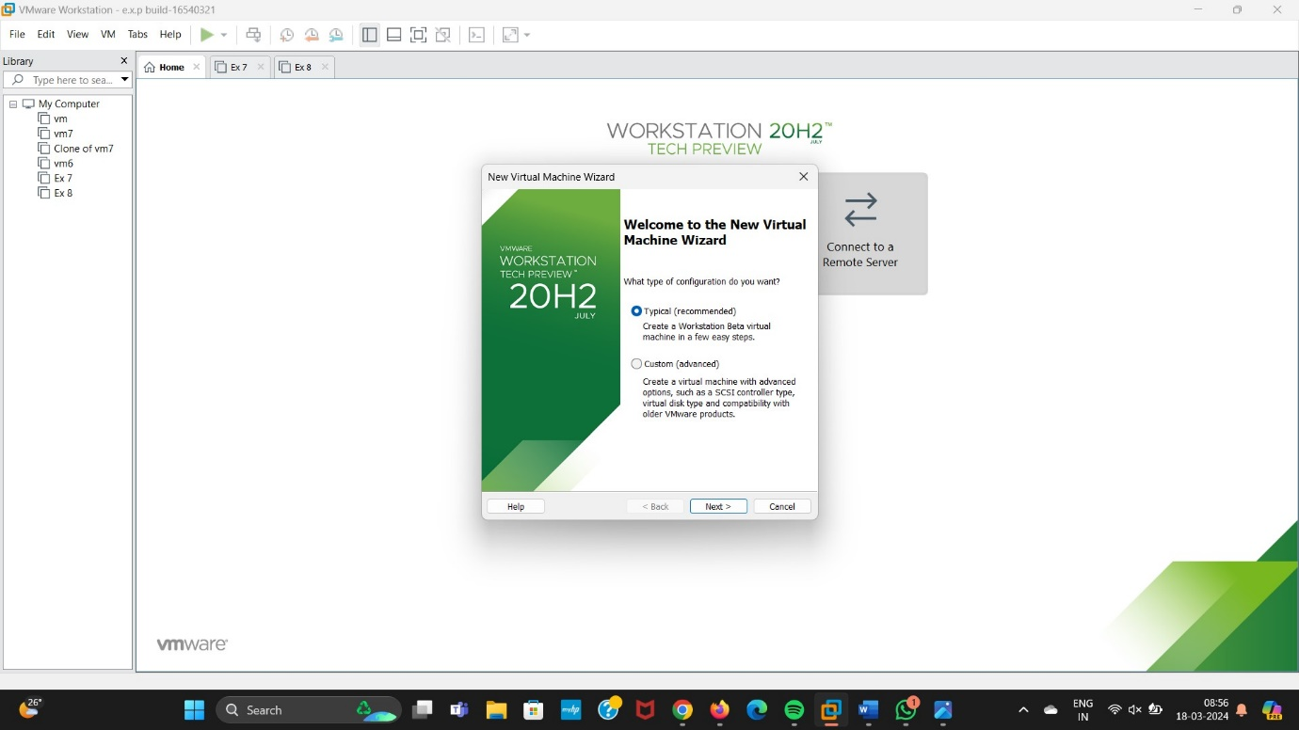

**Step 2:** Click On I will install the Operating System Later.

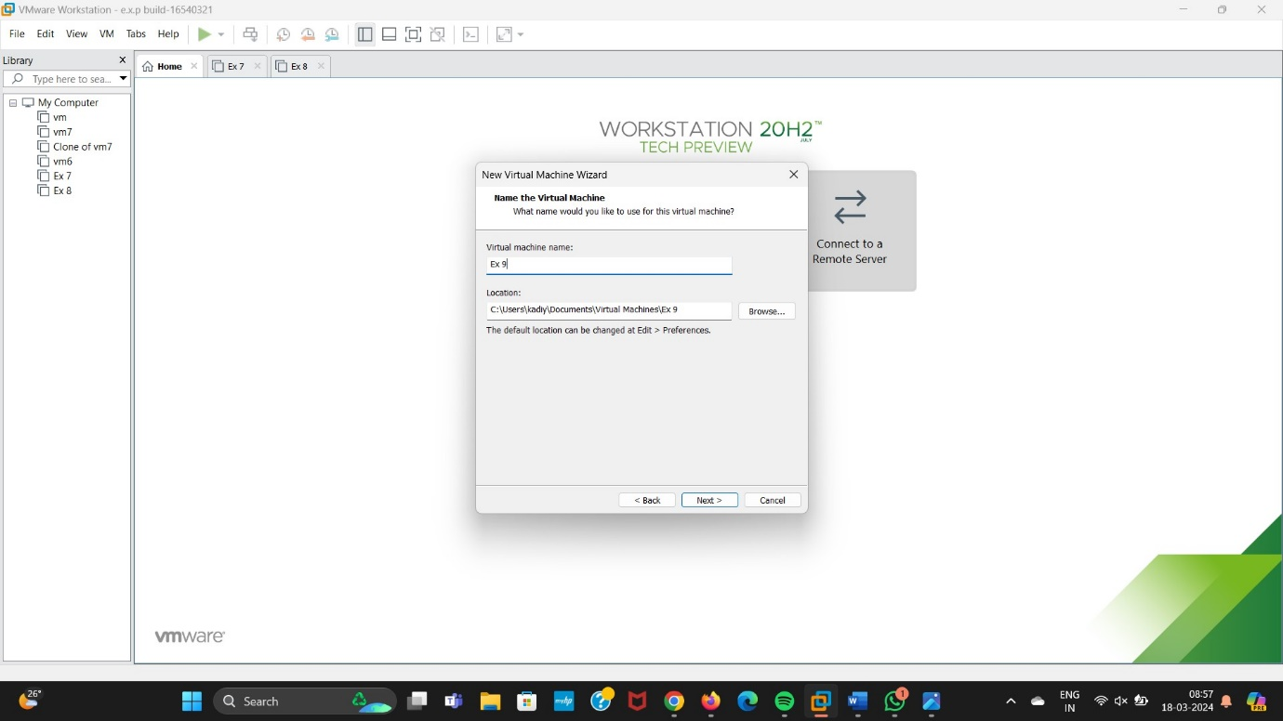

Step 3: Click On Finish Button.

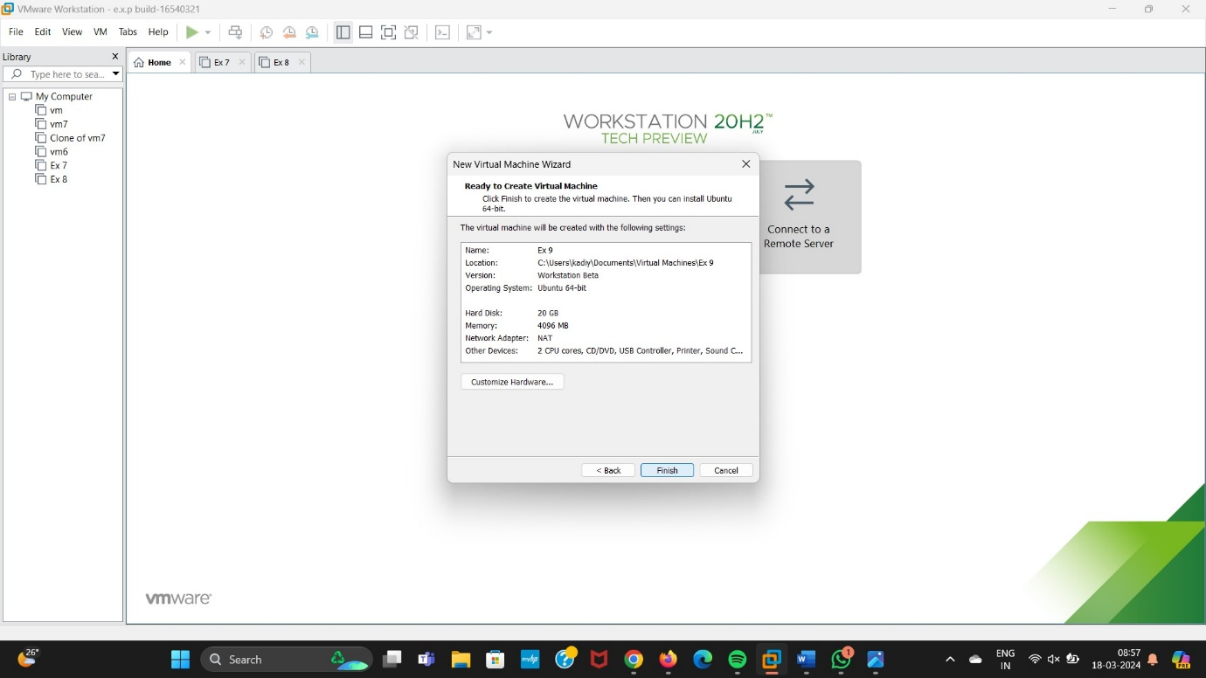

Step 4: Select VM Option and Give a Name and enter the Description.

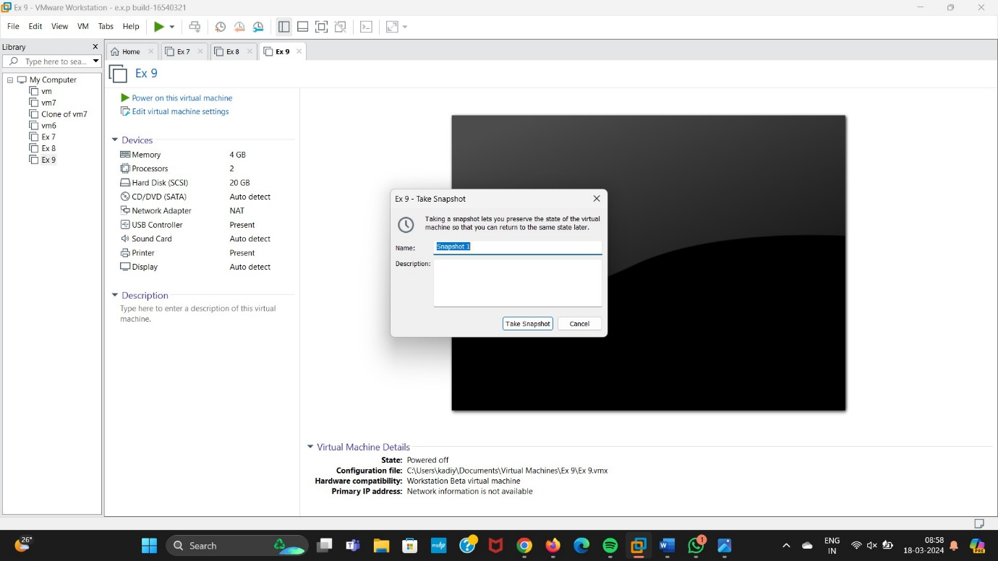

Step 5: Output Of the Snapshot.

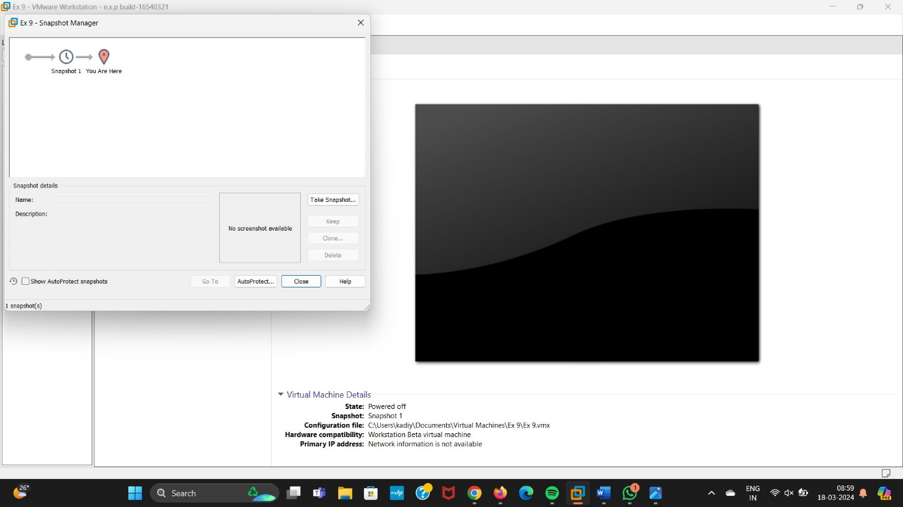

Step 6: Output for the 3 Snapshots.

